Official Gazette Book No.242 Volume A (May 2008)

Page No.: 911

(210) Application No.: 4-2008-04421 (220) Application Date: March 6, 2008
(441) Publication Date: May 26, 2008
(531) International Classification of Figure 2.5.1; 2.5.3; A11.3.7
(540) Sample of Trademark: (731) Name of Applicant: SHIGEMITSU INDUSTRY CO., LTD (JP)

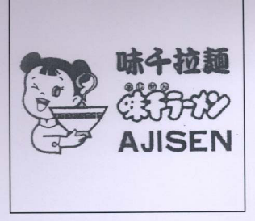

Address: 1-14-63, Kuwamizu, Kumamoto-shi, Kumamoto-Ken, Japan
(740) IP Agent: GINTASSET CO., LTD

(511) List of Goods/Services Bearing Trademark (in accordance with International Classification)
Class 30: Noodles including Chinese noodles, instant Chinese noodles, “udon” noodles, instant “udon” noodles, “soba” noodles, instant “soba” noodles, spaghetti, macaroni, pasta, flour for food, rice including enriched rice, artificial rice, canned rice, dried cooked-rice, rice cake; dumpling stuffed with meat, steam pies stuffed with meat, steam dumpling stuffed with meat, baked dumpling stuffed with octopus, sushi, sandwiches, pizzas, box lunches, hotdogs, hamburgers, seasonings, spices, flavoring for cooking, cooking salt, dressings for salad, sauces.
Class 43: Restaurant services, catering services and delivery services, featuring menu items composed of Chinese dishes mainly composed of noodle, Kwangtung dishes, Sichuan dishes, Shanghai dishes, Beijing dishes; Japanese dishes including “udon” or “soba” noodles, eel dishes, “sushi” dishes, “tempura” dishes, cutlet dishes, Oriental dishes, Indian dishes; bar service namely serving beverages composed of alcoholic beverages, tea, coffee, cocoa, soft drink or fruit beverages.

